**ASSIGNMENT -4**

*TITLE :- ANALYZING THE PERFORMANCE*

* *INTRODUCTION*:-

APPLE INC.( Apple Computer, Inc.) is an American multinational corporation and technology company headquartered in Cupertino, California, in Silicon Valley. It designs, develops, and sells consumer electronics, computer software, and online services. Devices include the iPhone, iPad, Mac, Apple Watch, Vision Pro, and Apple TV; operating systems include iOS, iPadOS, and macOS; and software applications and services include iTunes, iCloud, Apple Music, and Apple TV+.

Apple inc. is an Consumer electronics Software services, Online services industry .

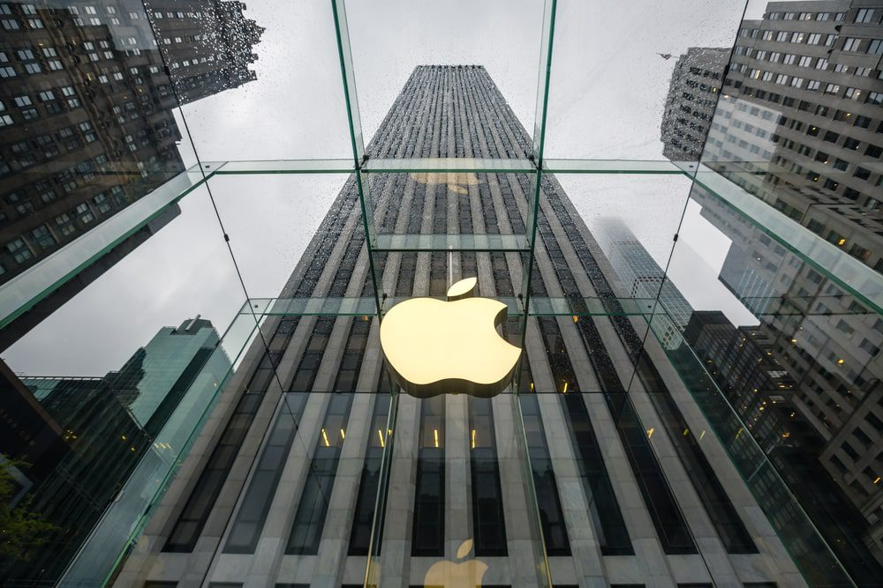

**DATA ANALYSIS**

* *GLOBAL RETAIL PRESENCE:-*

Apple has a strong global retail presence, with over 500 stores in 23 countries, as per Statistics. This extensive retail network provides consumers with easy access to Apple products and services.

* *KEY BENEFITS OF APPLE INC.*

1. High-quality hardware.
2. User-friendly interface.
3. Robust security features.
4. Consistent software updates.
5. Seamless integration with other Apple devices.
6. Strong app ecosystem.
7. Sleek and professional design.

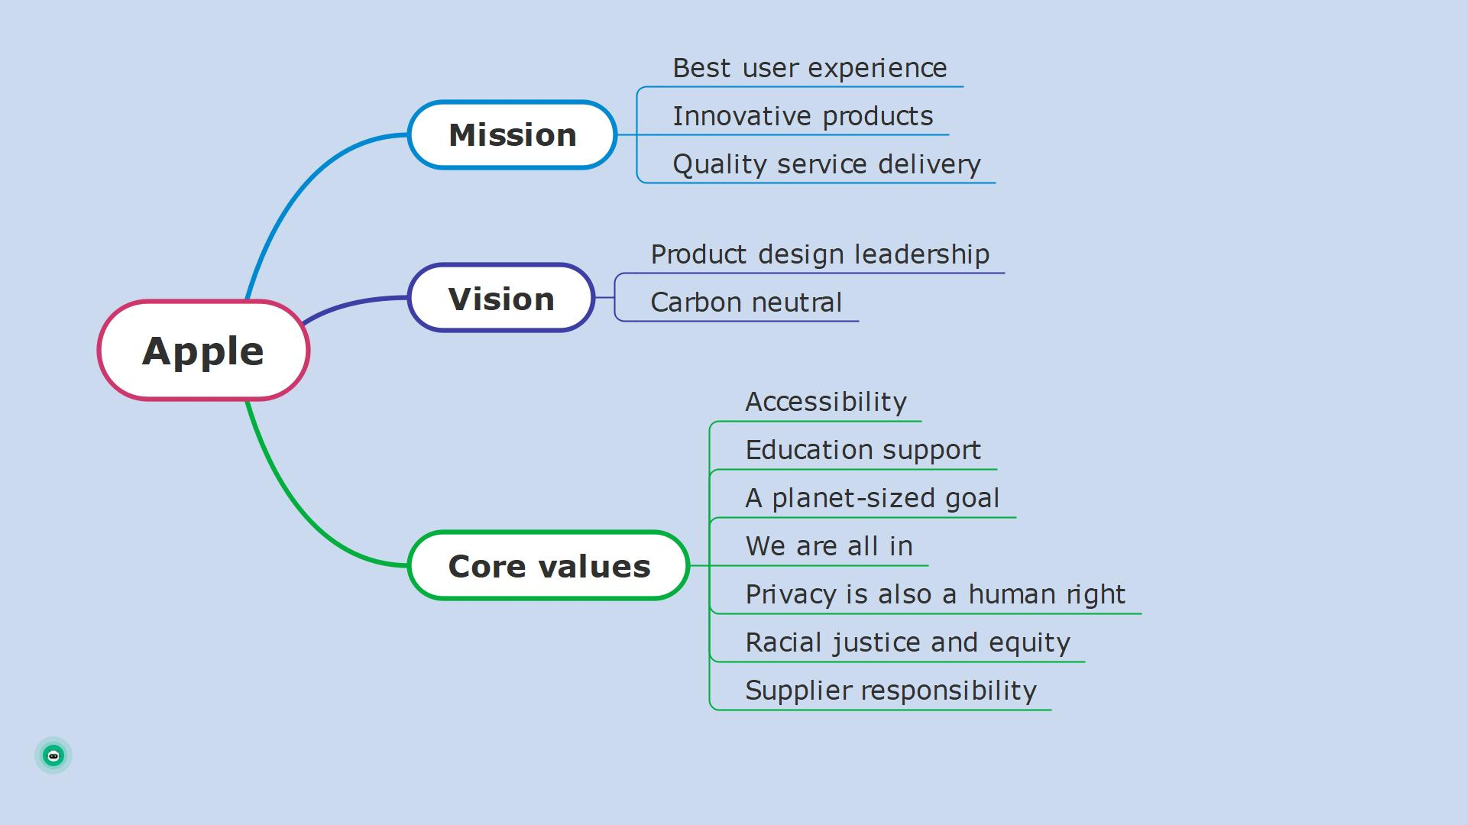

* *HISTORICAL STOCK PRICE :-*

PREVIOUS CLOSE $170.03

DAY RANGE $168.23$169.34

YEAR RANGE $159.78$199.62

MARKET CAP 2.61T USD

AVG VOLUME 66.75M

P/E RATIO. 26.30

DIVIDEND YIELD 0.57%

PRIMARY EXCHANGE NASDAQ

Market Capitalization 2.6T

Book Value $4.79

Dividend Share 0.95

Dividend Yield 0.56%

Earnings Per Share (EPS) 6.43

PE Ratio 26.67

PEG Ratio. 2.11

Wall Street Target Price 185.81

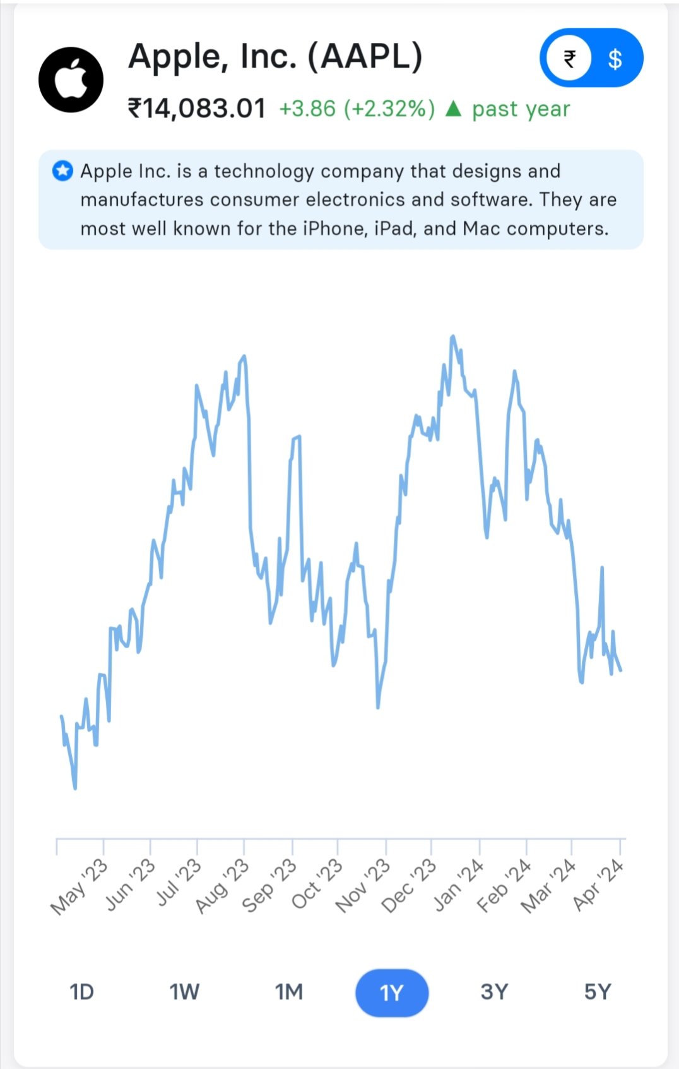

HISTORICAL STOCK

HISTORICAL STOCK PRICE DATA CHART.

* KEY METRICS:-
* The latest closing stock price for Apple as of April 01, 2024 is 170.03.
* The all-time high Apple stock closing price was 197.86 on December 14, 2023.
* The Apple 52-week high stock price is 199.62, which is 17.4% above the current share price.

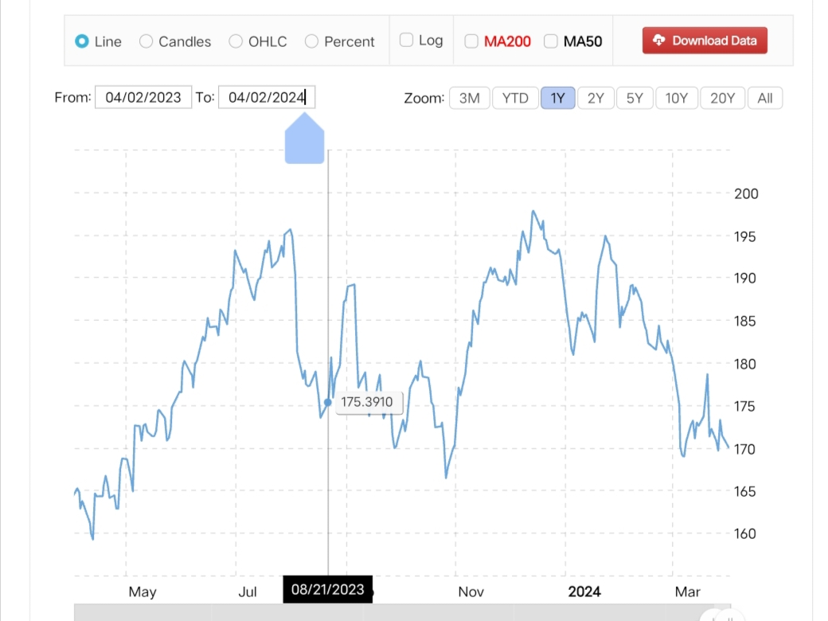

|  |  |  |  |  |  |  |
| --- | --- | --- | --- | --- | --- | --- |
| Year | Average Stock Price | Year Open | Year High | Year Low | Year Close | Annual % Change |
| 2024 | 181.5362 | 185.4044 | 194.9323 | 169.0000 | 170.0300 | -11.57% |
| 2023 | 171.9066 | 124.2202 | 197.8586 | 124.1706 | 192.2856 | 49.00% |

* ***VOLATILITY****:-*

Volatility is a statistical measure of the dispersion of returns for a given security or market index, it shows how the price swings around its mean. The volatility here is measured as the annualized standard deviation between monthly returns from the security over the past year. In most cases, the higher the volatility, the riskier the security.

As per (2023-04-02), Apple’s Volatility is 17.45%.

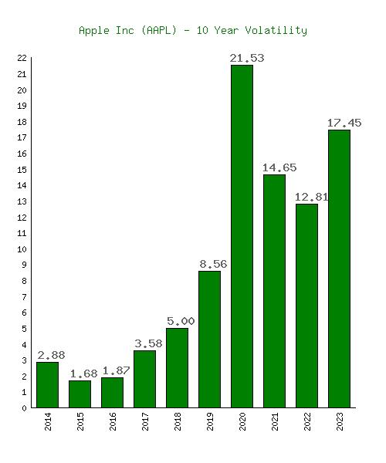

* ***STANDARD DEVIATION:-***

Apple Inc has current Standard Deviation of 1.28. The Standard Deviation is a measure of how spread out the prices or returns of an asset are on average. It is the most widely used risk indicator in the field of investing and finance. Standard Deviation is commonly used to measure confidence in statistical conclusions regarding certain equity instruments or portfolios of equities.

Standard Deviation=SQRT(V) = 1.28

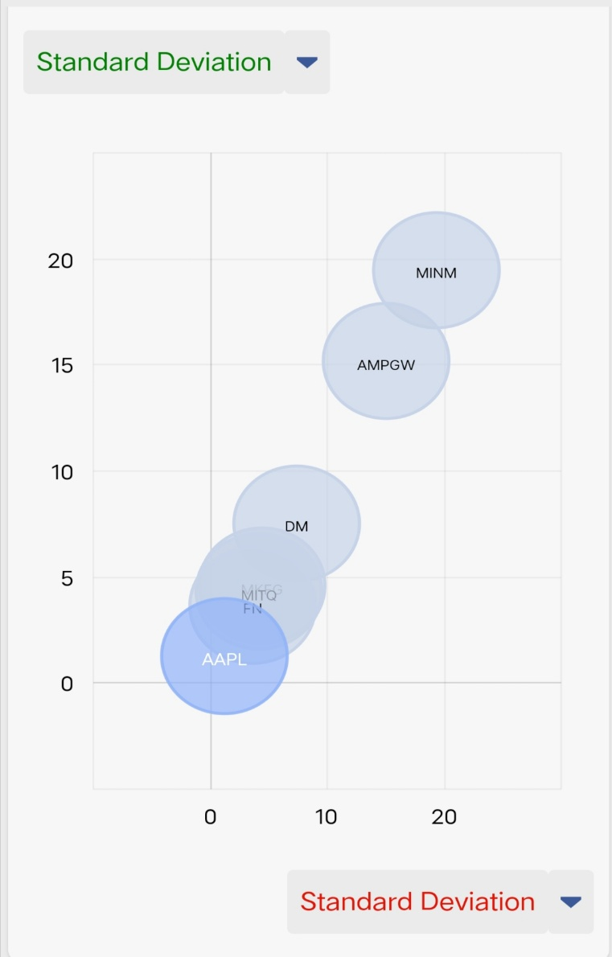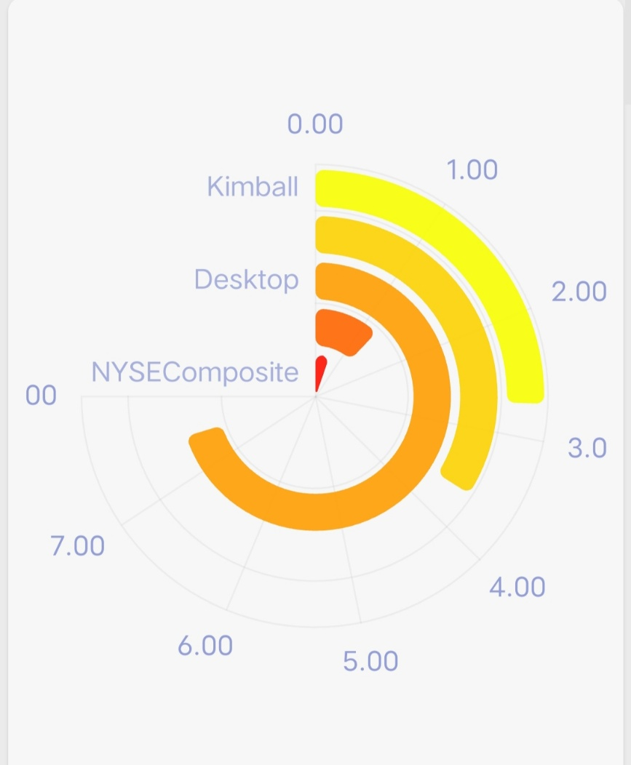

* ***AVERAGE TRADE VOLUME:-***

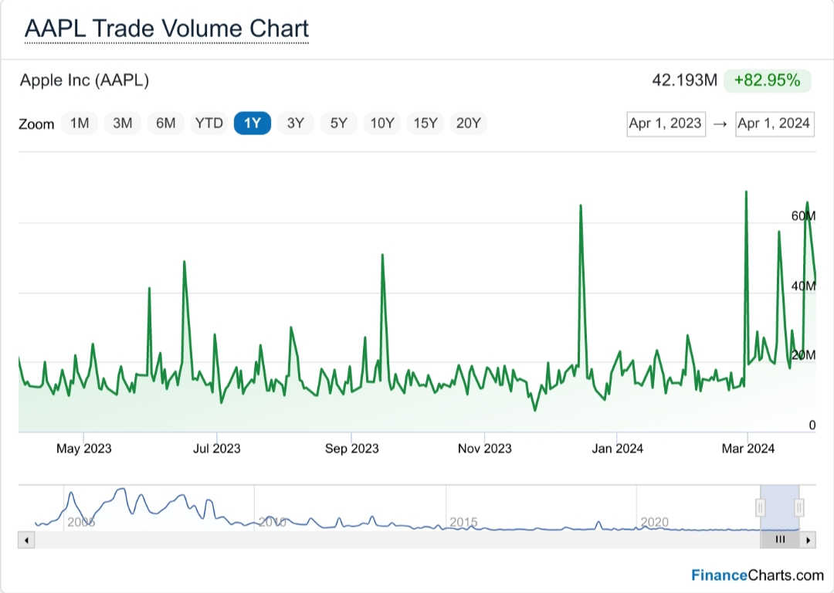

**AVERAGE TRADE VOLUME OF APPLE COMPANY**

* ***COMPARE PERFORMANCE TO RELEVANT INDEX:-***

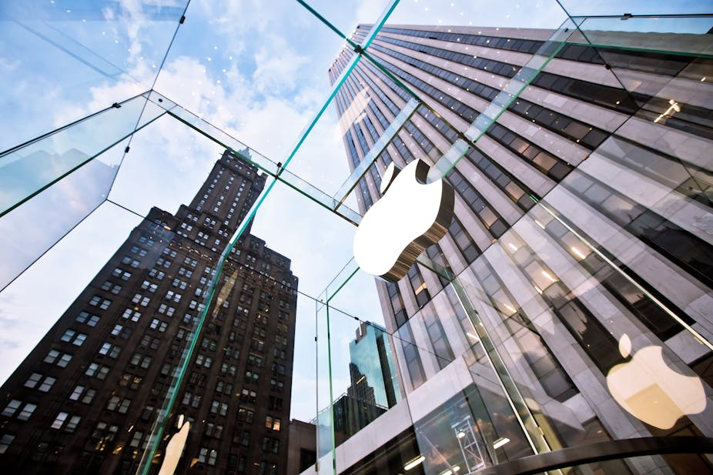

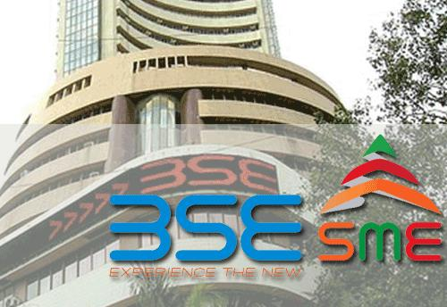

1. Bombay Stock Exchange (BSE) – India

BSE is the oldest stock exchange in Asia and the first in India. It was established in 1875 and is located in Mumbai. It is the fastest stock exchange in the world by the number of trades executed per day. BSE has more than 5,500 listed companies, making it one of the world’s largest stock exchanges by the number of listed companies. It has a market capitalization of around $3 trillion as of March 2023.

1. NASDAQ – United States of America

NASDAQ, on the other hand, is an American stock exchange that was established in 1971. It is the second-largest stock exchange in the world by market capitalization, behind the New York Stock Exchange (NYSE). It is known for its electronic trading platform and is home to many high-technology companies such as Apple, Microsoft, and Amazon. NASDAQ has a market capitalization of around $19 trillion as of March 2023.

**PRICE INFORMATION**

EXCHANGE BSE NASDAQ

Open 52,877.16 169.08

High 52,973.07 169.34

Low 52,614.49 168.23

Last 52,925.04 168.84

Change +226.04 -1.19

% Change +0.43% -0.70%

Volume 0 49,329,398

20-Day Average Volume 0 68,682,375

Previous Close 52,699.00 170.03

Industry N/A . Computer – Mini

Has Options No Yes

**TECHNICALS**

20-Day Moving Average. 52,348.14 171.90

20-Day Raw Stochastic 92.96% 5.84%

20-Day Relative Strength 64.04% 38.95%

Weighted Alpha +43.81 -3.36

Today’s Opinion 100% Buy 88% Sell

Previous Opinion . 100% Buy 88% Sell

Last Month’s Opinion 88% Buy 24% Sell

**PERFORMANCE**

5-Days

|  |  |  |
| --- | --- | --- |
| %Chg | +1.11% since 06/18/21 | -1.18% since 03/25/24 |
| Low | 51,740.19 on 06/21/21 | 168.23 on 04/02/24 |
| High | 53,057.11 on 06/22/21 | 173.60 on 03/27/24 |

1-Month

|  |  |  |
| --- | --- | --- |
| %Chg | +4.52% since 05/25/21 | -6.02% since 03/01/24 |
| Low | 50,620.45 on 05/26/21 | 168.23 on 04/02/24 |
| High | 53,057.11 on 06/22/21 | 178.67 on 03/20/24 |

3-Month

|  |  |  |
| --- | --- | --- |
| %Chg | +9.26% since 03/25/21 | -9.05% since 01/02/24 |
| Low | 47,204.50 on 04/22/21 | 168.23 on 04/02/24 |
| High | 53,057.11 on 06/22/21 | 196.38 on 01/24/24 |

6-Month

|  |  |  |
| --- | --- | --- |
| %Chg | +12.67% since 12/24/20 | -2.83% since 10/02/23 |
| Low | 46,160.46 on 01/29/21 | 165.67 on 10/26/23 |
| High | 53,057.11 on 06/22/21 | 199.62 on 12/14/23 |

**KEY STATISTICS**

Market Capitalization, $K N/A 2,625,583,040

Shares Outstanding, K N/A 15,441,881

Annual Sales 0 383,285,000,000

Annual Net Income 0 96,995,000,000

Last Quarter Sales N/A 119,575,000,000

Last Quarter Net Income N/A 33,916,000,000

60-Month Beta N/A 1.27

**PER-SHARE INFORMATION**

Most Recent Earnings N/A 2.18 on 02/01/24

Latest Earnings Date N/A 05/02/24

Most Recent Dividend N/A 0.240 on 02/09/24

Next Ex-Dividends Date N/A 02/09/24

**RATIOS**

Price/Earnings ttm N/A . 26.71

* ***ANALYSING SIGNIFICANT EVENTS OR NEWS :-***

**Apple’s Worldwide Developers Conference returns June 10, 2024**

****Entire conference available online for all developers, with a special event at Apple Park on June 10.

CUPERTINO, CALIFORNIA Apple today announced it will host its annual Worldwide Developers Conference (WWDC) online from June 10 through 14, 2024. Developers and students will have the opportunity to celebrate in person at a special event at Apple Park on opening day.

Free for all developers, WWDC24 will spotlight the latest iOS, iPadOS, macOS, watchOS, tvOS, and visionOS advancements. As part of Apple’s ongoing commitment to helping developers elevate their apps and games, the event will also provide them with unique access to Apple experts, as well as insight into new tools, frameworks, and features.

“We’re so excited to connect with developers from around the world for an extraordinary week of technology and community at WWDC24,” said Susan Prescott, Apple’s vice president of Worldwide Developer Relations. “WWDC is all about sharing new ideas and providing our amazing developers with innovative tools and resources to help them make something even more wonderful.”

Developers and students will be able to discover the latest Apple software and technologies by tuning into the keynote, and they can experience WWDC24 throughout the week on the Apple Developer app, Apple Developer website, and YouTube. This year’s conference will include video sessions and opportunities to engage with Apple designers and engineers and connect with the worldwide developer community.

WWDC24 will include an in-person experience on June 10 that will provide developers the opportunity to watch the keynote at Apple Park, meet with Apple team members, and take part in special activities. Space will be limited, and details on how to apply to attend can be found on the Apple Developer site and app.

Apple is proud to support the next generation of developers through the Swift Student Challenge, one of many Apple programs that seek to uplift the next generation of developers, creators, and entrepreneurs. On March 28, this year’s applicants will be notified of their status, and winners will be eligible to apply for the in-person experience at Apple Park. Fifty Distinguished Winners, who are recognized for outstanding submissions, will be invited to Cupertino for a three-day experience.

Apple will share additional conference information in advance of WWDC24 through the Apple Developer app and website.

THANKYOU

P.VYSHNAVI 121128807066. DR L.B COLLEGE AU